

The Decorative Motifs on Tang Dynasty Mirrors

Author(s): Chuan-Ying Yen

Source: *Cleveland Studies in the History of Art,* Vol. 9, Clarity and Luster: New Light on Bronze Mirrors in Tang and Post-Tang Dynasty China, 600-1300: Papers from a Symposium on the Carter Collection of Chinese Bronze Mirrors at the Cleveland Museum of Art (2005), pp. 1-10

Published by: Cleveland Museum of Art

Stable URL: <http://www.jstor.org/stable/20079750>

Accessed: 24/05/2011 15:10

Your use of the JSTOR archive indicates your acceptance of JSTOR's Terms and Conditions of Use, available at <http://www.jstor.org/page/info/about/policies/terms.jsp>. JSTOR's Terms and Conditions of Use provides, in part, that unless you have obtained prior permission, you may not download an entire issue of a journal or multiple copies of articles, and you may use content in the JSTOR archive only for your personal, non-commercial use.

Please contact the publisher regarding any further use of this work. Publisher contact information may be obtained at <http://www.jstor.org/action/showPublisher?publisherCode=cma.>

Each copy of any part of a JSTOR transmission must contain the same copyright notice that appears on the screen or printed page of such transmission.

JSTOR is a not-for-profit service that helps scholars, researchers, and students discover, use, and build upon a wide range of content in a trusted digital archive. We use information technology and tools to increase productivity and facilitate new forms of scholarship. For more information about JSTOR, please contact [support@jstor.org](mailto:support@jstor.org).

|  |  |
| --- | --- |
|  | *Cleveland Museum of Art* is collaborating with JSTOR to digitize, preserve and extend access to *Cleveland Studies in the History of Art.* |

CHUAN-YING YEN The Decorative Motifs on Tang

Dynasty Mirrors

The casting of bronze mirrors with elaborate decoration on the reverse can be traced back in Chinese history to the beginning of the Bronze Age. Not only were such mirrors used in daily life, they were also considered sacred objects. Many scholarly studies on the decor of

Fig. 1. Plate with Embossed Figure of Shapur II Hunting Lions, Sassanian, 4th century, partially gilded silver, Diam. 22.9 cm.The State Hermitage Museum, St. Petersburg. After Ryoichi Hayashi, *The Silk Road and the Shoso-in,* trans. Robert Ricketts (New York:Weatherhill, 1975), pl. 140.

mirrors of the Han dynasty (206 BC—AD 220) have addressed the symbolic portrayal of the universe and the forces within it. By the Tang dynasty (618-9o7), however, the happiness of this world as well as glorification

of the ideal world appear in mirror decoration.' The celestial context of the ornamentation gradually gave way to the idealization of a blissful land. Undoubtedly, the Tang people regarded bronze mirrors as durable

precious treasures. Materials such as gold, silver, and mother-of-pearl were expressively applied, with imaginative birds and flowers, fantastic animals, and grapevines floating exuberantly across these sumptuous surfaces.2

In major museum collections around the world, Tang mirrors of exquisite quality often stand out from other bronze decorative art.

Furthermore, Tang mirrors survive in noticeably larger quantities than earlier bronze mirrors, which suggests a growing presence at that time of socially and economically prominent gentry and merchants. Wealthy cosmopolitan patrons living in this prosperous and stable time created a

market of sumptuous artistic connoisseurship that reached its peak around the late seventh to the beginning of the eighth century. As Professor Ju­hsi Chou has pointed out,3 the dynastic capitals, or at times secondary capitals, tended to be centers for the production and consumption

of mirrors. By the Tang dynasty, in addition to the capitals,Yangzhou produced exquisite mirrors and sent the best ones to the imperial court as tribute."

The opening of China's frontiers and the influx of Buddhist culture brought with it new inspiration for the vocabulary of decorative art. Many novel and exotic foreign objects were imported along the silk routes. At the same time, the Chinese worked on their own innovative ideas to fulfill their sense of creativity.s The imperial house patronized skilled metalsmiths and cultivated the taste for refined details, luxuriant designs, and inlays such as lacquer, glass, gold, and silver. The refined techniques developed in gold and silver ware, such as the Sassanian silver plate with partially gilded embossed figures (fig. 1), provided critical inspiration for the production ofTang mirrors.

The cosmopolitan culture of Tang China not only reflected intensive interests in western counterparts, but also exerted a strong impact on Korea and Japan in the east. In fact, many superb Tang mirrors among those best known today are in the Shoso-in repository of the Tociai-ji monastery at Nara in Japan. This legendary collection of imported Tang decorative art was primarily inherited from Emperor Shomu (r. 724-749).The emperor, a devoted Buddhist, made the initial

|  |  |
| --- | --- |
| Fig. 2. Octafoil Bracket-lobed Mirror with Landscape [picturing the realm of immortals] and the Eight Divinatory Trigrams, silvered bronze, Diam. 40.7 cm. Shoso-in, Nara. After *Nihon bijutsu zenslal* (Tokyo: Gakusha Kenkyajo, 1978), 5: 53. |  |

dedication of precious religious implements to the eye-opening ceremony of the bronze Great Buddha of the Todai-ji in 752. After Shomu died in 756, his widow, the dowager empress Komyo, dedicated to the Buddha more than one thousand items from the late emperor's favorite personal and household belongings in five installments!' Included in this mid eighth-century repository are many Tang artworks ranking from fairly high to the very best quality, even by Chinese standards.

The legacy of the Sh5so-in collection provides us profound examples for the technical excellence and exquisite design ofTang decorative art. The large quantity of mirrors (more than fifty) in

the collection demonstrates that bronze mirrors were indeed highly appreciated by the court. Notable in this context is the eight-lobed mirror with silver back depicting the realm of the immortals (fig. 2).

Luxurious Tang mirrors preserve the world of artistic imagination as well as the cultural memory of the people at the time. To understand fully the iconology of the decorative motifs on these mirrors, one has to look further into decorative arts such as textiles, gold and silver, pottery, and architectural decoration. In general, however, unlike the abstract

cosmological patterns of the Han TLV mirrors,' those of the Tang era focus more closely on the living world of birds and flowers, animated animals, and idealized immortals living in a scenic garden. The following paper discusses four types of ornamentation of Tang mirrors: floral motifs, birds and flowers, plants and animals, and landscapes and figures.

*Floral Motifs*

Floral motifs are probably the most common decoration on Tang mirrors. In addition to depictions of peony, camellia, and gardenia on the backs, the contours of many mirrors are themselves designed to imitate that of a full-blown flower with six or more petals. A splendid example is an eight‑

lobed mirror with floral motif in the Sumitomo collection of the Sen­oku Hakko Kan (fig. 3). In the outer circle, an array of eight large floral patterns fills up the entire space with a sense of voluptuous elegance. A mirror of similar design is in the Carter collection (fig. 4); both are in the style of the eighth century.

Fig. 3. Eight-lobed Mirror with Eight Blossoms, 8th century. Sumitomo collection, Sen-oku Hakko Kan, Kyoto. After Higuchi Takayasu, *Kyookan* (Kyoto: Senoku Hakko Kan, 199o), pl. 87.

Fig. 4. Lobed Mirror with Six Blossoms, 8th century, Diam. 19.1 cm. The Cleveland Museum of Art, Gift of Drs. Thomas and Martha Carter in Honor of Sherman E. Lee, 1995.36o.

|  |  |
| --- | --- |
| Fig. *5.* Lotus-flower-shaped Pedestal, lacquer and gold-leaf on wood, H. 17 cm. Shoso-in, Nara. After *Nihon bijutsu zenshtl,* 5: 94, 95• |  |

In fact, variations of lobed and foliated mirrors became the favorite contours of the Tang craftsman. The popularity of flower motifs, especially that of the lotus flower, has always been associated with the demands of Buddhism. For example, a brilliantly painted and gilded wood object in the form of a lotus (fig. 5) presumably served as a base for an offering lamp used in a temple. The icon of a fully blossoming lotus flower is

also a prominent decorative element in Buddhist architecture in the Yungang cave temples during the Northern Wei dynasty around the 46os. Moreover, from early Buddhism on, lotus flowers were widely applied

to halos, for instance, to symbolize the brightness of Buddha's wisdom. However, we should not overlook the fact that as early as the Han dynasty, the lotus flower was often painted on the ceiling of a tomb chamber

to symbolize the celestial body.' Therefore, the widely applied lotus flower on mirrors seems to be a happy combination of ancient symbolic association and newly popularized Buddhism.

Besides the lotus flower, floral motifs on Tang mirrors were often inspired by sophisticated designs on textiles imported from the Near East through the Silk Road. With great enthusiasm, Tang emperors demanded that scholars in the court prepare meticulous records and studies of the exotic plants, animals, and artifacts brought by foreign envoys.9 Such records provided a wide-ranging array of innovative ideas to the delight of the aristocratic society in the capital.

The roundel pattern in the center of the Shaso-in mirror with mother-of-pearl inlay (fig. 6) is as splendid as that of a multicolored rug. Four smaller roundels appear equally spaced in the outer circle. Set against a black lacquer background, mother-of-pearl as well as amber,

tortoise shell, and rock crystal are employed to compose a fantastic design. The iridescent brilliance of the mother-of-pearl and the bright colors

of the stones achieve a glittering effect on the surface, at the same time suggesting volume and mass in their curvilinear forms.

Another powerful example of floral motifs is seen on the gold and glass-backed cloisonné mirror (fig. 7). Of shiny silver on the front, on the back are three overlapping layers of six-lobed lotus-flower patterns in gold and cloisonné enamels.The striking lotus petals are covered with patterns and stripes in relief in green, black, and brown, imitating the taste of

|  |  |
| --- | --- |
| Fig. 6. Mirror, mother-of-pearl inlay, Diam. 27.2 cm. Shoso-in, Nara. After *Nihon bijutsu zenshu, 5:* 49, so. |  |

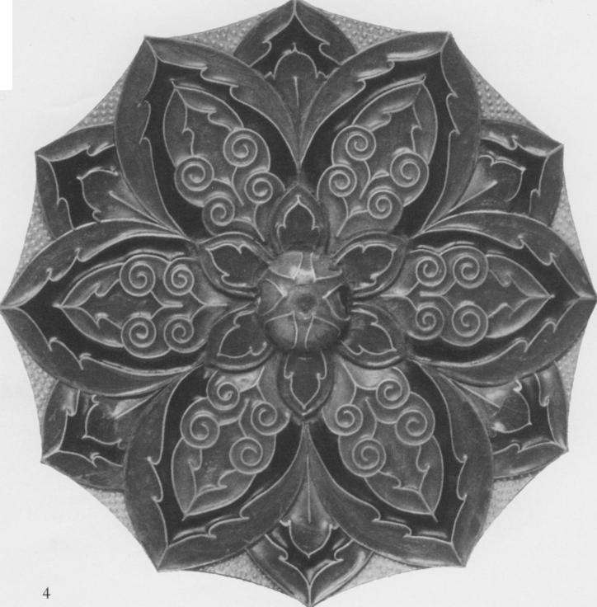

Fig. 7. Mirror, silver with gold and glass (cloisonné enamel) inlay, Diam. 18.5 cm. Shoso-in, Nara. After *Nihon bijutsu zensha,* 5: 51.

three-color pottery popular at the time. The distinct sculptural quality sets it apart from other Tang mirrors, and it is unique in every aspect of design, material, and technique.

Fig. 9. Mirror with *Pingtuo (Heidatsu)* Decoration, 8th century, H. 14.9 cm. Asia Society; New York, Mr. and Mrs. John D. Rockefeller III Collection of Asian Art, 1979.119.

|  |  |
| --- | --- |
| Fig. 8. Mirror *with Pingtuo (Heidatsu)* Decoration, 8th century, Diam. 19.2 cm. The Cleveland Museum of Art, Leonard C. Hanna Jr. Fund, 1973.74. |  |

*Birds and Flowers*

Bird-and-flower motifs, especially that of a bird holding a flowering branch in its beak, are considered auspicious signs in Chinese tradition. Floral patterns and blossoms take on an almost metaphysical quality in the lively design of an eight-lobed mirror backed with gold and silver in the Cleveland Museum of Art collection and a square one with a similar design in the Asia Society collection in New York (figs. 8, 9).A special technique of decoration, called *pingtuo* in Chinese or *heidatsu* in Japanese, is applied to this type of mirror. Delicate designs of birds, flowers cut

in gold, and silver leaves are embedded in a lacquered surface. Against the black-lacquer background, the thin strips of gold and silver decor display a distinctive high luster. Although different in shape, these two

mirrors follow the same symmetrical design order and can be dated to the beginning of the eighth century.

One of the strengths of the Tang mirrors in the Carter collection falls in the category of simple yet elegant bird-and-flower mirrors (fig. Io). An interesting comparison is offered by a piece in the National Palace Museum,Taipei (fig. ii). Serenity permeates the compositions of these two eight-lobed mirrors.A pair of ducks or phoenixes in flight, symbolizing auspiciousness and happiness in marriage, makes mirrors of this kind precious presents for weddings and other occasions. In addition, the brilliant rosette pattern on the top of the mirror in the National Palace Museum and the symmetrical branches of flowers on the Carter mirror each display a sense of harmony and prosperity appropriate for good wishes.

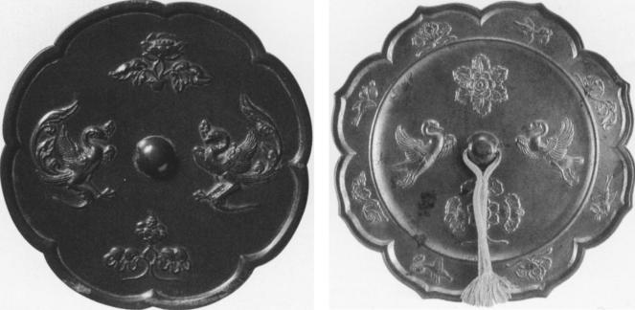

Fig. io. Mirror with Paired Phoenixes and Floral Displays, 8th century, Diam. 14.8 cm.The Cleveland Museum of Art, Gift of Drs.Thomas and Martha Carter in Honor of Sherman E. Lee, 1995.348.

Fig. ii. Flower-shaped Mirror with Lotus and Pair of Ducks, 8th century, Diam.

18.2 cm. National Palace Museum, Taipei, Li 74.18. After *Gugong tongjing tezhan*

*tulu* [Catalogue of a special exhibition of bronze mirrors] (Taipei: National Palace Museum, 1986), pl. III.

*Plants and Animals*

Undoubtedly, animal-and-grapevine mirrors are the most famous Tang mirrors. Such mirrors are well documented and make up the largest group from the tombs dated between 664 and 711.10 Grapes were introduced into China from the west as early as the Han dynasty." Animal-and-grapevine mirrors characterize best the sculptural quality and compelling energy of the Tang culture in the latter half of the seventh

to the beginning of the eighth century. The decorations on two mirrors in the Carter collection (figs. 12, 13) demonstrate the excellence of the type.The more sophisticated one (fig. 13) displays a delight of energy and abundance. Heavy grapevines and grapes float into the background like a melody eulogizing the world of bird and animal. In the center field, playing in the midst of grapevines, six lion-like creatures, including the one crouching in the middle, each look in various directions in metaphysical poses. In the outer field, birds either spread their wings or stand still vigilantly. Realistic details of the animals, such as their fur and spines, are carefully described to attract the attention of the viewer.

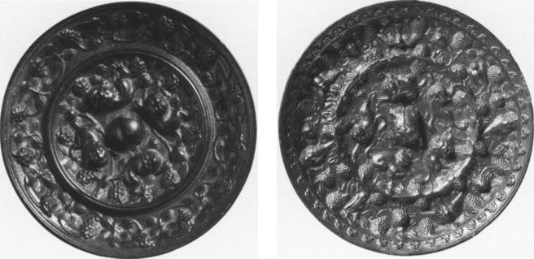

Fig. 12. Animal-and-Grape Mirror, mid 7th century, Diam. 8.2 cm.The Cleveland Museum of Art, Gift of Drs.Thomas and Martha Carter in Honor of Sherman E. Lee, 1995.356.

Fig. 13. Animal-and-Grape Mirror, late 7th century, Diam. 13.9 cm.The Cleveland Museum of Art, Gift of Drs. Thomas and Martha Carter in Honor of Sherman E. Lee, 1995.355.

Simple but vigorous designs of bird and animal are set against a clear background in the bracket-shaped mirror in the collection of the Arthur M. Sackler Museum, Harvard University. In the large center field, amid scrolls of fully blossoming flowers, two fantastic animals and two phoenixes occupy the four directions. The joyfully strutting lions each raise one paw and hold a flowering branch in another paw while looking at phoenixes perching in the back. In the narrow outer field,

Fig. 14b. Detail showing inscribed date under the inset plaque [note: the

inscription was incised in the mold and appears backwards on the mirror]. Arthur M. Sackler Museum, Harvard University Art Museums, Bequest of Grenville L. Winthrop, 1943.52.168. Photograph courtesy Arthur M. Sackler Museum, Harvard University.

|  |  |
| --- | --- |
| Fig. I4a. Mirror with Foliate Rim and with Inset Silver Plaque, dated 693, cast bronze with inset silver repousse plaque, Diam. 15.8 cm. Arthur M. Sackler Museum, Harvard University Art Museums, Bequest of Grenville L. Winthrop, 1943.52.168. Photograph courtesy Arthur M. Sackler Museum, Harvard University. |  |

peaceful garden scenes with birds and flowers are depicted. Mirrors of this type have been found in tombs datable to the period from 690 to 71o.

A related bronze mirror, also at the Sackler museum (fig. i4a), provides additional documentation. An inscription incised under the silver backing of the mirror bears the date of 693 (fig. 14b).'' The knob at the center assumes a crouching zoomorphic form, from which radiate six circles. Inside each circle a striding animal reaches out to touch its enclosing vine scroll with its paws.The outer circle of the mirror is decorated with eight brackets, each depicting either a branch of a flower or a bird.

Before closing the discussion on animal motifs, let us consider

one last but not the least important subject—the dragon mirror. Closely identified with Chinese culture and commonly employed as a decorative motif in every artistic medium since the Shang dynasty *(c. i600—m23 Be),* dragon mirrors seem to have become popular in the eighth century. A mirror in the Carter collection presents a full moon in the shape of

a dragon (see p. 43, fig. 2). The dragon's head and neck twist up to the right, legs up in the air and wide-open mouth touching the knob of the mirror. Small puffs of cloud emerge from the feet and float into the sky. The curvilinear movement of the composition and powerful modeling of the dragon in this type of mirror demonstrate well the compelling forces of the universe.

*Landscape and Human Figures*

Human figures appear in Tang mirrors first as part of hunting scenes, a motif popular in the mural painting of the imperial tombs dating from the late seventh to the beginning of the eighth century. The theme of hunting for pleasure took another ancient and metaphysical form as the

search for immortality; as early as the Warring States period (481-221 Bc), in many tombs the soul of the deceased riding on a dragon on the way to immortality was depicted." Two splendid examples are in the Sumitomo and the Carter collections (figs. 15, 16).The simplified rocks with vegetation on the Carter mirror indicate the land of the immortals; on the Tokyo mirror, a cloud leads each dragon or phoenix to the ideal world.

|  |  |
| --- | --- |
| Fig. 15. Eight-lobed Mirror with Four Immortals, 8th century. Sumitomo collection, Sen-oku Hakko-kan. After Higuchi Takayasu, *Kyookan,* pl. 97. |  |

|  |  |
| --- | --- |
| Fig. 16. Octafoil Mirror with Hunters and Prey, late 7th—early 8th century, Diam. 19.9 cm. The Cleveland Museum of Art, Gift of Drs. Thomas and Martha Carter in Honor of Sherman E. Lee, 1995.365. |  |

The most elaborate depiction of the Taoist realm of the immortals is the large silver-backed mirror in the Shoso-in (fig. 2). Encircling

the outer frame of the mirror, full-fledged geese, ducks, peacocks, and phoenixes perch on large flower heads attached to long baroque scrolls. The landscape depicting an auspicious land of happiness in the large inner circle is a new motif of Tang mirrors. Like pivots of the four quarters,

mountains rise above the ocean in the center. In the intermediate spaces appears either a flying dragon or a gentleman playing music accompanied by a dancing crane. This delightful and detailed composition must have derived from the emergence of the mature landscape painting style in the eighth century.

By the mid eighth century, the human figure appears in the landscape, relaxing in a confined corner of a private garden. A lobed mirror with a tortoise knob, musician, and phoenix (see p. 56, fig. 12) is a good example. In front of the bamboo grove, a musician or immortal sits down to play for the dancing phoenix. In between, a lotus pond is decorated with rocks. A mirror with a comparable motif was excavated

from a tomb in Luoyang dating to 784:4 The back of this mirror is inlaid with mother-of-pearl in a bold pictorial rendition of a joyful garden party (see p. 36, fig. II). At either side of a blossoming tree sits a gentleman entertained by wine and music. The rest of the space is filled with an attendant, a few birds, rocks, and wine vessels. The soft and voluminous rendering of the motif characterizes that of the Tianbao era (742-755) or even later.

The elaborate ornament of meticulously depicted flowers and animals in these mirrors celebrates the good wishes and prosperity enjoyed by the Tang people. Concern with naturalism and a search for ideal beauty compete with each other within the design. The cosmopolitan culture in the capital opened up a new range of imagination and expression for

the artists and artisans. The mature style of Tang art captures the enduring energy of the universe in microcosm.

NOTES

1. Chuan-yingYen, "Tangdai tongjing wenshi zhi neirong yu fengge" [Decorative patterns on Tang bronze mirrors], *Bulletin of the Institute of History and Philology,* Academia Sinica, 60, part 2 (1989), 289­*353.*
2. Kong Xiangxing, "Sui tang tongjing de leixing yu fenqi" [Typology and periodization of Sui and Tang mirrors], in *Zhongguo kaogu xuehui di yi ci nianhui lunwenji* (Beijing:Wenwu, 1980), 380-99.
3. Ju-hsi Chou, *Circles of Reflection: The Carter Collection of Chinese Bronze Mirrors* (Cleveland: Cleveland Museum of Art, 2000), 7.
4. One of the earliestYangzhou mirrors was produced in mid autumn of 622 and inscribed as a tribute to the court on the first day of 623. Wang Fu, *Chongxiu Xuanhe bogutu (c. 117o-80)* [Revised illustrated antiques of the Xuanhe era *(c.* 1170-80)], reprint of 1603 edition (Taipei: Xinxing, 1969), 29: 16.
5. Jessica Rawson, "The Ornament on Chinese Silver in the Tang dynasty (AD 618-906)," *British Museum Occasional Paper,* no. 40 (London: British Museum, 5982), 1.
6. Ryoichi Hayashi, *The Silk Road and the ShOsii-in,* trans. Robert Ricketts, vol. 6 of *Heibonsha Survey ofJapanese Art* (NewYork: Weatherhill, 1975), 34-62.
7. The TLV pattern resembles the three Roman letters; it is thought to have cosmological significance.
8. Hayashi Minao, "Chilgoku kodai ni okeru renge no shocho" [The symbol of the lotus flower in ancient China], *T5h5 Gakuho* 59 (1987), 1-61.
9. Emperor Taizong, for instance, ordered just such a careful official record in

647. See *Tang hui yao* [Tang dynasty encyclopedia] (Taipei: Shi jie shu ju, 1960), 100: 1796.

1. At least fifteen animal-and-grape mirrors have been discovered in dated tombs; the earliest one is dated 664; see *Wenwu,* no. 7 (1972), 33-41. For the list of dated tombs with animal-and-grapevine mirrors, see Yen, "Tangdai tongjing," 335.
2. Schuyler Cammann, "The Lion and Grape Patterns on Chinese Bronze Mirrors," *Artibus Asiae* 16 (1953), 265-91.

12.The inscription was first published by Umehara Sueharu, *Toky5Taikan* [Conspectus ofTang mirrors] (Kyoto: Dohosha, 1984, reprint of 1945 edition), pl. 99b and pp. I00-I01.

1. Sofukawa Hiroshi, "Kandai gazoseki niokeru shosenzu no keifu" [The lineage of ascending immortals in the pictorial stone of the Han dynasty], *Toho Gakuho 65* (1993), 23-221.
2. *Wenwu,* no. 5 (1956), 41-44.